RENEWABLE ELECTRICITY PRODUCTION VS CONSUMPTION

The 2 data set is consisting of Renewable electricity output (% of total electricity output)

and Renewable energy consumption (% of total final energy consumption) of 11 countries in years between 2001 to 2015. The data set is taken from world bank api. The 11 countries are Australia, China, Canada, Finland, India, Maldives, Russia, New Zealand, Germany, United States and Argentina.

From the 11 countries in 15 years 25.43% of total production of electricity was by renewable and at side of consumption only 16.89% is renewable. From the 11 countries the top 5 countries in production and consumption of renewable energy are

**Production**

**Consumption**

|  |  |  |
| --- | --- | --- |
| **Rank** | **Country** | **Percentage** |
| 1 | New Zealand | 69.83 |
| 2 | Canada | 60.88 |
| 3 | Argentina | 33.14 |
| 4 | Finland | 31.71 |
| 5 | China | 17.69 |

|  |  |  |
| --- | --- | --- |
| **Rank** | **Country** | **Percentage** |
| 1 | India | 45.03 |
| 2 | Finland | 33.29 |
| 3 | New Zealand | 29.8 |
| 4 | Canada | 21.93 |
| 5 | China | 17.59 |

In the view of production New Zealand and Canada is at 1 and 2 place but in consumption it falls to 3rd and 4th place. Top 1st and 2nd place is taken by India and Finland.

**Variance**

As we consider the variance of the dataset the total variance of the production and consumption are as follows

**Production**

**Consumption**

|  |  |  |
| --- | --- | --- |
| **Rank** | **Country** | **Percentage** |
| 1 | Germany | 44.64 |
| 2 | Argentina | 24.44 |
| 3 | New Zealand | 24.00 |
| 4 | Finland | 22.68 |
| 5 | China | 4.46 |

|  |  |  |
| --- | --- | --- |
| **Rank** | **Country** | **Percentage** |
| 1 | India | 45.03 |
| 2 | Finland | 33.29 |
| 3 | New Zealand | 29.8 |
| 4 | Canada | 21.93 |
| 5 | China | 17.59 |

Considering the variance in production Germany and Argentina are at 1st and 2nd place while in consumption it is again India and Finland.

**Standard Deviation**

As we investigate spread i.e., standard deviation of the data set we can see the following fig (Fig 1) as an output

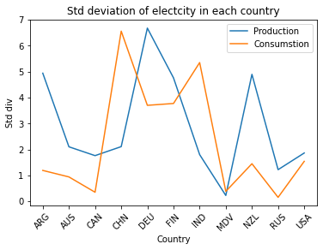

**Fig 1**

In production China and in consumption Denmark have highest standard deviation in the dataset.

**Correlation**

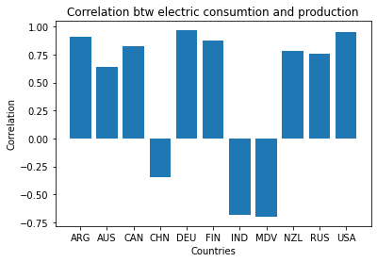

**Fig 2**

In the total 11, 3 countries have negative correlation and all other 8 have positive correlation.

In total 11 countries 8 have higher positive correlation i.e., correlation coefficient higher than 0.5 are

Germany: 0.97

United States: 0.95

Argentina: 0.91

Finland: 0.88

Canada: 0.83

New Zealand: 0.78

Russia: 0.76

Australia: 0.64

There are only 2 countries which have high negative correlation, India with -0.68 and Maldives with

-0.7. if we investigate countries which has low correlation there is only one country which is China

with -0.35

**Time series correlation**

Time series correlation of each country is

Australia: 0.32

China: 0.45

Canada: 0.74

Finland: 0.89

India: 0.22

Maldives: 0

Russia: 0.91

New Zealand: 0.9

Germany: 0.32

United States: 0.68

Argentina: 0.79

In case of Maldives due to insufficient data it results in 0. The result is displayed in the fig 3

**Fig 3**